## Assignment 2

For this assignment, use this document as a template for your answers: Fill out your answers directly in the relevant blank spaces. You may be concise in answering but do use complete sentences and justify your answers. You can use the reserved blank space to estimate the required length of the answer.

## Task 1: Recap on user groups and context of use

* Read this blog post: [User Experience: Primary and Secondary Users in Healthcare](https://medium.theuxblog.com/user-experience-primary-and-secondary-users-in-healthcare-8dd4c5c61490) by Nicholas Tenhue on Medium
* Describe two sets of primary and secondary user groups for the SISU system (Information system for education, [https://sisu.lut.fi](https://sisu.lut.fi/)).  
    
  To get started, consider for example the two scenarios: 1) A student meeting with study office to sign up late for courses. Who is the primary and who is the secondary user? 2) A student meeting with their study advisor to show and ask advice about their personal study plan (HOPS / PSP[1]). Explain your choices with few sentences – there are several correct ways to present the scenarios.
  1. Primary users: Students, Teachers. They have direct influence on SISU as teachers will organize course plans and students will enroll in courses in SISU. This is done regularly by both students and teachers.
  2. Secondary users: Administrative staffs, External users (visitors to SISU, students from other universities, etc.). Administrative staffs use the information provided by SISU to designate teaching premises, set up exams or send out feedback forms to enrolled students. External users visit the site to look up for information of a course.

Note! A way to describe a large group of people is to group them according to their behavior (frequency of use), user goals (i.e., what do the user want to achieve by using your service?), user domain knowledge (i.e. some users are experts on the domain), likelihood of use (how likely these users are going to become a regular users?). You can read more [here](https://www.nngroup.com/articles/everyone-as-users/), on how to get past the “our users are everyone”.

* Select one of the user groups and, describe in detail ONE context of use of the SISU system: PRIMARY USERS
  1. Tasks context: Teachers use SISU to plan courses, set up classes (lectures, tutorials, exercises, etc.), and upload students’ final grades. Students use SISU to enroll in courses, check where a class takes place, make a PSP, send messages to administrative staffs, and receive their final grades.
  2. Physical context: Being an online website, SISU is not always subjected to physical impacts of the outside world. However, in a remote location where the Internet is not stable, accessing SISU might be a problem. In urban areas where Internet is fast and reliable, users can connect to SISU with ease.
  3. Social context: SISU is adopted to be use in an academic atmosphere; therefore, it should be logical, compact and efficient. Teachers should plan lectures and tutorials of a course in a convenient and accessible manner. Students are expected to enroll in courses, finish them on time and adjust their performance by self-evaluating grades uploaded to SISU.
  4. Technical context: SISU requires an Internet connection to access and a database to store its content (courses, classes, students’ information, etc.). SISU also needs monthly maintenances and regular updates to function properly. SISU has a security feature to prevent unauthorized access and protect sensitive information from being leaked.

Note! Contexts of use and user groups were presented in detail in topic 1 lecture on PACT. Topic 2 lecture on understanding users has good material on personas / user groups.

## Task 2: Conceptual modeling

A conceptual model contains the metaphors, relationships, concepts, and descriptions related to a system. The language used in the conceptual model is the user’s language, not e.g., names of software components. A conceptual model is visualized e.g., by a diagram which shows: the main building blocks of the system and their parts and which user tasks and actions each part serves. See below (Fig 1.) an example of task analysis (borrowing a book from the library) through a conceptual model.

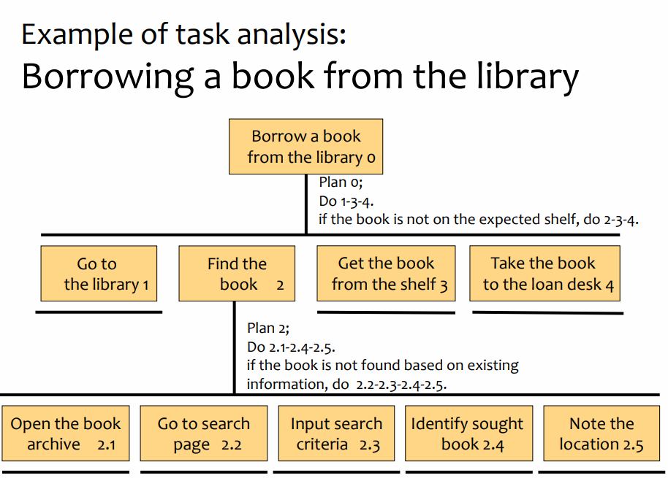

Fig 1: Example of a conceptual model of borrowing a book from the library

Read and watch the following content before proceeding to the task on the next page:

* We Think Therefore It Is – Conceptual Modelling for Mobile Applications by the Interaction Design Foundation. URL: <https://www.interaction-design.org/literature/article/we-think-therefore-it-is-conceptual-modelling-for-mobile-applications>
* Design of Everyday Things - Conceptual Model & System Image (youtube video). URL: <https://www.youtube.com/watch?v=shSCUNxtn18>
* What is a mental model (youtube video). URL: <https://www.youtube.com/watch?v=nAgXISssAws&feature=emb_title>
* Conceptual models: begin by designing what to design (2002) by Jeff A. Johnson and Austin Henderson. URL: <https://www.researchgate.net/publication/220382707_Conceptual_models_begin_by_designing_what_to_design>

### Explain: What is a mental model?

A mental model is what the user believes about a system. This model isn't based on facts, but is instead constructed primarily on the person's past experiences and what they “think” they know about the system. These beliefs affect the way we need to design because people base their actions according to their mental model. So when the system doesn't work the way people expect, they get confused (NNgroup, 2018).

### Explain: What is a conceptual model?

A conceptual model is a description of how something should be done. It dictates the organization and operations of a system. It specifies and describes: the major design metaphors and analogies employed in the design, if any; the concepts the system exposes to users, including the task-domain data-objects users create and manipulate, their attributes, and the operations that can be performed on them; the relationships between these concepts; the mappings between the concepts and the task-domain the system is designed to support (Johnson and Henderson, 2002).

### Explain: What is not a conceptual model?

A conceptual model is not the user interface as it does not describe the appearance, the features or the functions of an interactive system; instead, it shows what users can do and what need to be understood to operate it. A conceptual model is not the users’ mental model since it is a design tool and should make sense to users based on their understandings; it forms the basis, not the primary purpose, of the mental models. A conceptual model is also a set of use cases because use cases focus on tasks, while the conceptual model focuses on the system. Finally, a conceptual model is not an implementation architecture: an implementation architecture might include objects of no concern to the users, which should not be omitted from the conceptual model (Johnson and Henderson, 2002).

### Citations:

1. Nngroup, 2018. *What is a Mental Model?* [online] Available at: https://www.youtube.com
2. Johnson, J., Henderson, A., 2002. Conceptual models: begin by designing what to design. *interactions*, **9**(1).

## Task 3: Conceptual modeling

Suppose you have just returned to your summer cottage after a long cold winter. You are ready to spend a relaxing weekend enjoying the peace of nature and the warmth of your sauna. Your sauna is very cold though, so you should warm it up. **Explain your conceptual model for warming up a cottage sauna using a combination of text and drawings.**

For Task 3, it is recommended that you draw using pen and paper, then take a photo with your mobile phone, and then insert the image here. If you do not have drawing supplies available, you may use any drawing or visual tool that is available. Do not hesitate to use your imagination and creativity – if you have not heated one before, the outcome of this task can demonstrate the differences in designer and user mental models.

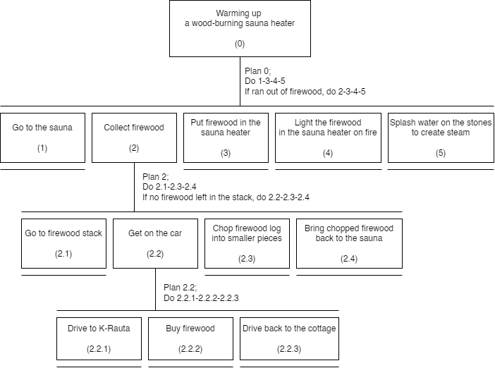

1. <https://elut.lut.fi/fi/opintojen-suorittaminen/opintojen-suunnittelu/opintosuunnitelma-hops> & <https://elut.lut.fi/en/completing-studies/planning-your-studies/personal-study-plan-psp>